Assignment 2.1
Task 1- Creating a directory/user/acadgild/hadoop
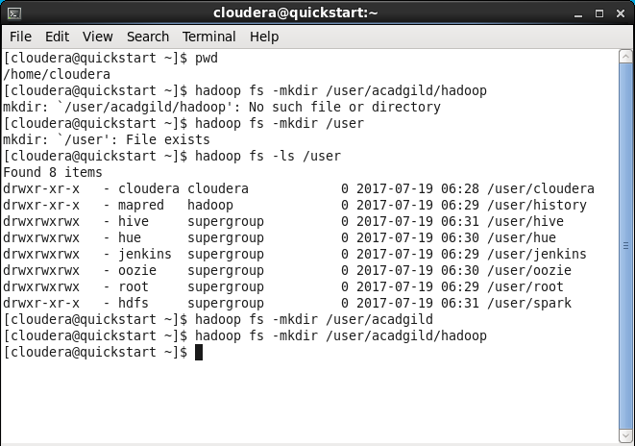

Task2- Creating a file in HDFS under directory/user/acadgild/hadoop, with name word-count.txt
